Digital PR Strategy – ReaXium
Paige Reid
Johns Hopkins University

- Organizational Overview

ReaXium is a biometric-based solutions provider aiming to strengthen the security and safety of communities in real-time through mobile and cloud-based software programs. The organization's audience includes men and women from 30-55 years old located in south Florida that are active in information services and technologies as well as strategy and operations consulting. The goal of the organization is to provide a wide variety of solutions in order to increase the security and safety measures of their clients' organizations and the surrounding community. Objectives that the company has in order to achieve its goals include increasing brand awareness to promote the products and services provided by ReaXium through a more substantial online presence regarding social media platforms. ReaXium has a reliable website that is very user-friendly. They monitor their performance and set goals by each quarter and are active on social media. They also have a brand guide that allows the marketing team to ensure that the content on social platforms is consistent with the organization's branding efforts. Although the organization has a reliable website, they do not have a social media content schedule and post the same content on multiple platforms. ReaXium also does not send email marketing campaigns at any given time to their customers. In order to track their successes on social media platforms, ReaXium uses Social Gest, which allows them to evaluate the performance of accounts in each social network every month. ReaXium analyzes the information from Google Analytics for strategy, and they also use Freepik and Powtoon for design purposes. Currently, ReaXium is active on Facebook, Twitter, LinkedIn, Instagram, and their website. The organization does not engage with their audience on any platform and posts the same content to each platform. Overall, ReaXium's current social media presence is far more advanced than its competitors' social media presence.

- Assessment of Current Communication

The current communication goals for ReaXium include making the brand known through all online actions and advertising planning on social networks. The organization wants to offer content of interest and value to increase the community of followers on social networks. Lastly, the organization wants to promote the brand's products or services to convert fans into customers. The objectives the organization wants to use in order to achieve these goals include a higher projection on LinkedIn and Facebook with more relevant content for potential business partners. ReaXium also wants to increase the CTA projection using cyclic lists on Twitter while utilizing brand projection through a portfolio design exhibition to show apps, devices, and utilities on Instagram. Lastly, they want to use bowl typography, 3D images, and asymmetric designs to follow the trends of 2020. The outreach strategy for the organization includes creating content for posts on their social media platforms and their blog #ReaXium. The main tactic is sharing information on current events happening in the mobile biometric solutions industry to emphasize how the solutions provided by ReaXium benefit the community. The marketing and design team consists of three people. Estefania Da Silva is the Creative Director and Marketing Leader, Gabriel Carrillo Munoz is the Web Designer, and Marjorie Figuera Perez is the Graphic Designer. They do not currently have measurable objectives since their main focus is an overall more significant brand presence on all social platforms. ReaXium tracks its traffic with Google Analytics but does not lay out specific numbers for each quarter. Overall, the company is not meeting their organizational goals based on the current state of their communication efforts. The organization does not initiate conversations with the audience and shows redundancy by posting the same information multiple times in multiple places. In order to increase brand awareness, the organization needs to create engaging content specifically for each platform while also sharing information that is relevant to the company.

- Web and Social Media Audit: Findings

The social listening tool I used in order to perform the web and social media audit for ReaXium is Brand24. Brand24 offers a 14-day free trial and provides a dashboard summary based on keywords for the project. The keyword I used for the listening tool was ReaXium. Keywords are the main keywords that will collect data. Required keywords are additional keywords that must be present in order for the data to be collected. The required keywords I chose were mobile biometric solutions, security, biometrics, schools, safety, and tt4s. The scope of the audit includes a summary of mentions, social media reach, as well as positive and negative interactions over 30 days.
ReaXium has an average digital presence that most companies tend to have in the 21st century. The company's digital presence lacks engagement on all of its social media platforms. It tends to post the same content to each social platform, which can be redundant for loyal customers. ReaXium has a website, Facebook, Twitter, LinkedIn, YouTube, and Instagram account. The strongest of them all is their website. The website is modern, well-organized, and thoroughly explains the overall basics of the company, its products, and its clients. It provides explanations of how their solutions are beneficial to their customers and the people who use their customer's services daily. The website also includes a newsletter titled "#Reaxium," where ReaXium employees can write a post on specific events happening in the biometric community. The newsletter also shows its competitors in the industry that they are knowledgeable about the latest information in the biometric industry. When comparing the ReaXium website to other companies in the biometrics field, ReaXium has one of the most visually appealing in terms of design and user-friendliness. Most of the other websites contain similar information on what the company does precisely, videos of how to use their products and services, as well as whom they work with currently. For example, when looking at one of ReaXium's top competitors, the company IdentiMetrics has a very outdated website. IdentiMetrics does not have consistent branding, and the website is very wordy. None of the other biometric websites included any newsletter, but they did include customer reviews, which ReaXium does not have on their website currently.
When reviewing the search engine results on Google for "Mobile Biometric Solutions," ReaXium shows up at number 12 on the second page out of about 10.5 million results. When searching for "mobile biometrics solutions for schools," ReaXium is the number 3 hit on the first page out of over 10.2 million results. Screenshots of the “ReaXium” search engine results are below.
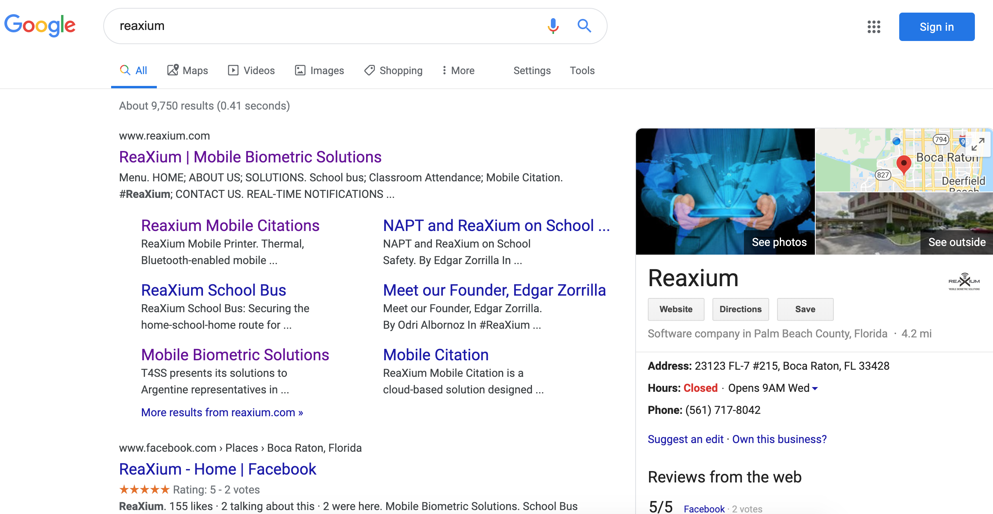
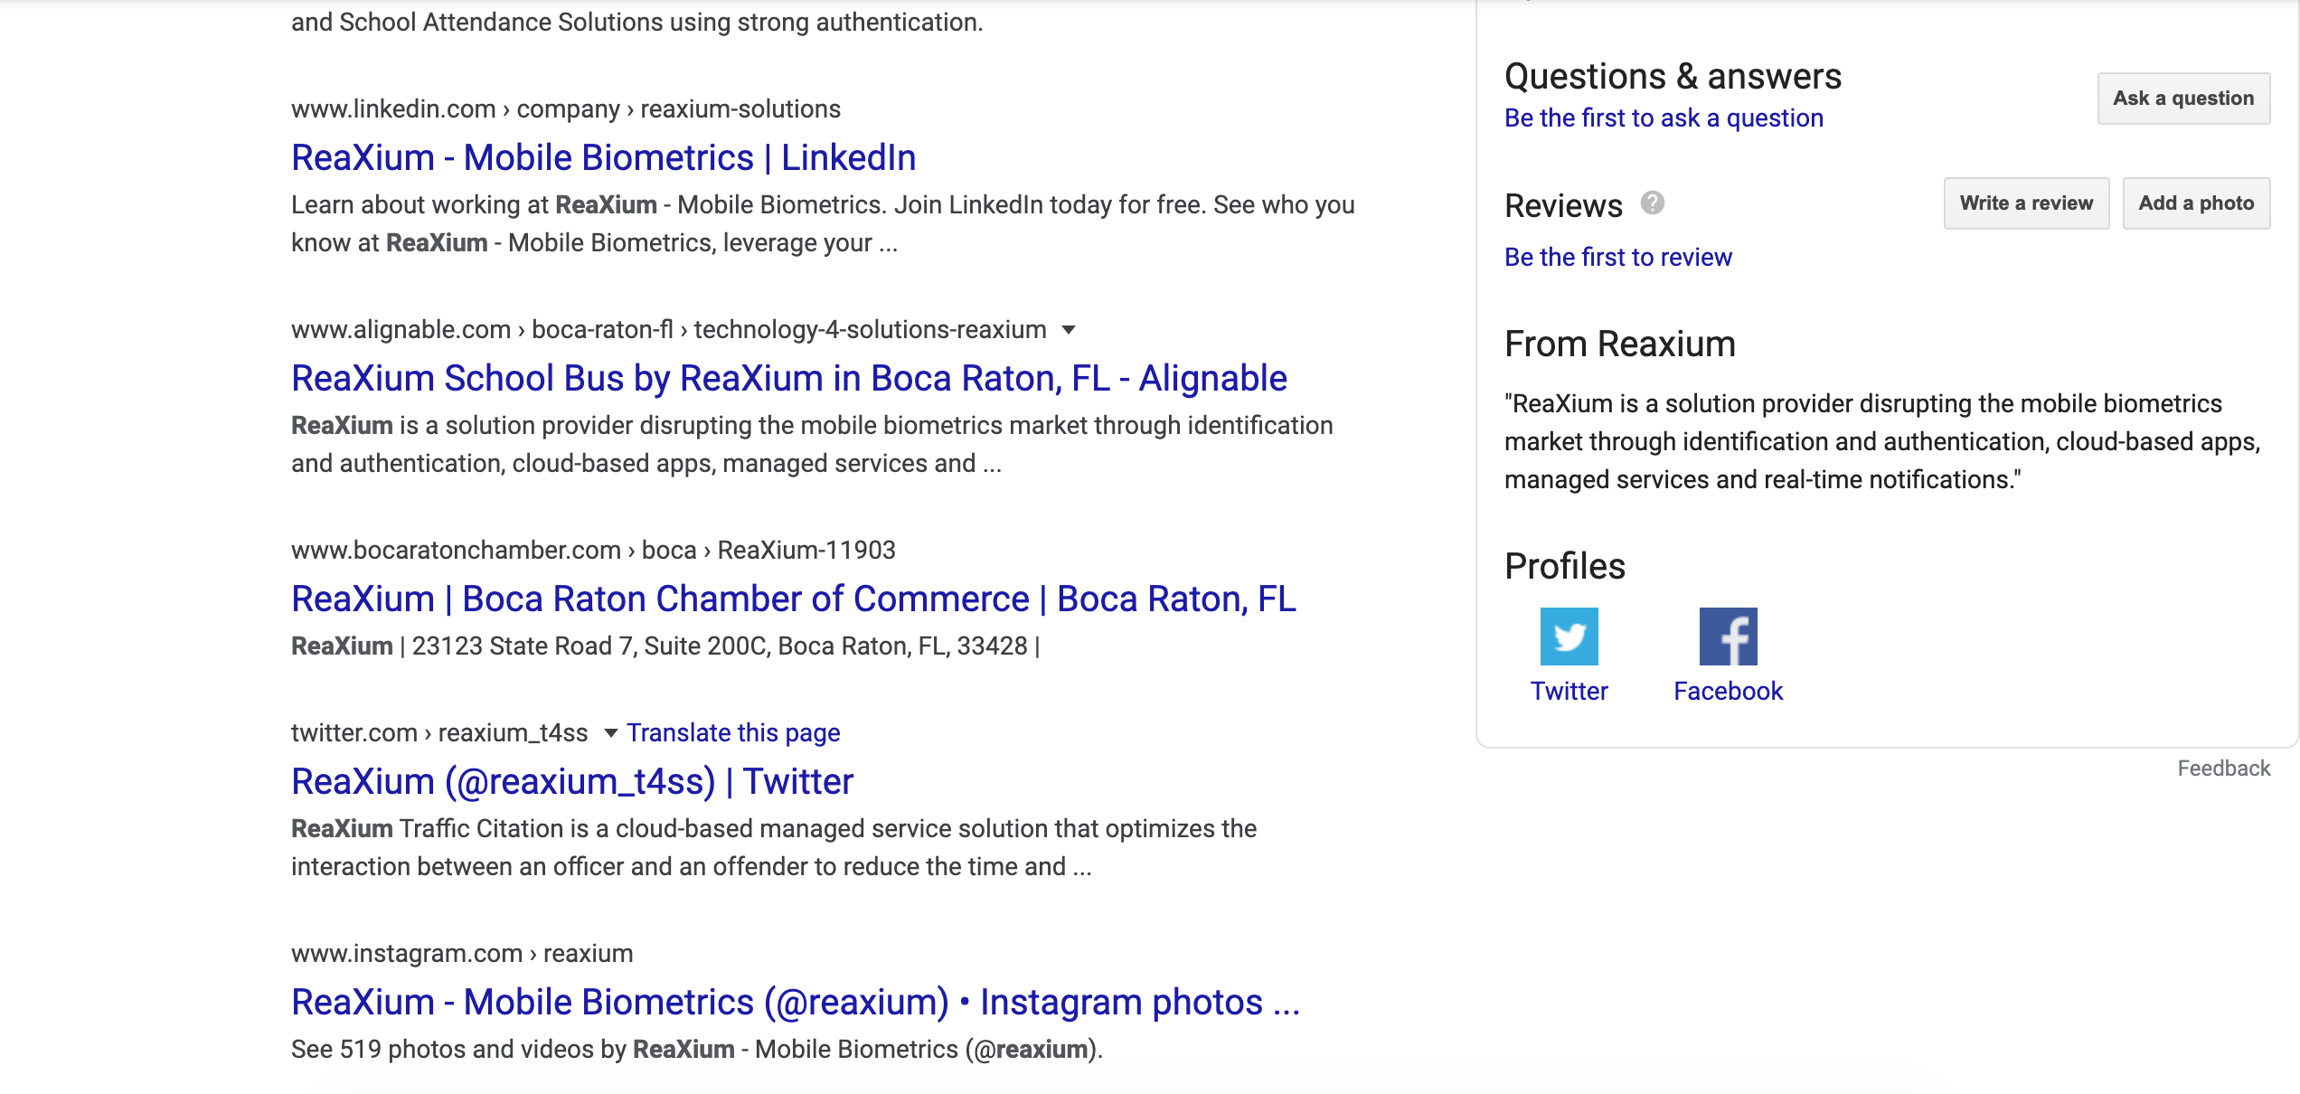

ReaXium shows a strong presence in the search engine since it is consistently pulling up the website along with all of its social media accounts. None of the search engine results are harmful to the organization's products or services, and the social listening summary tool also shows this information below.

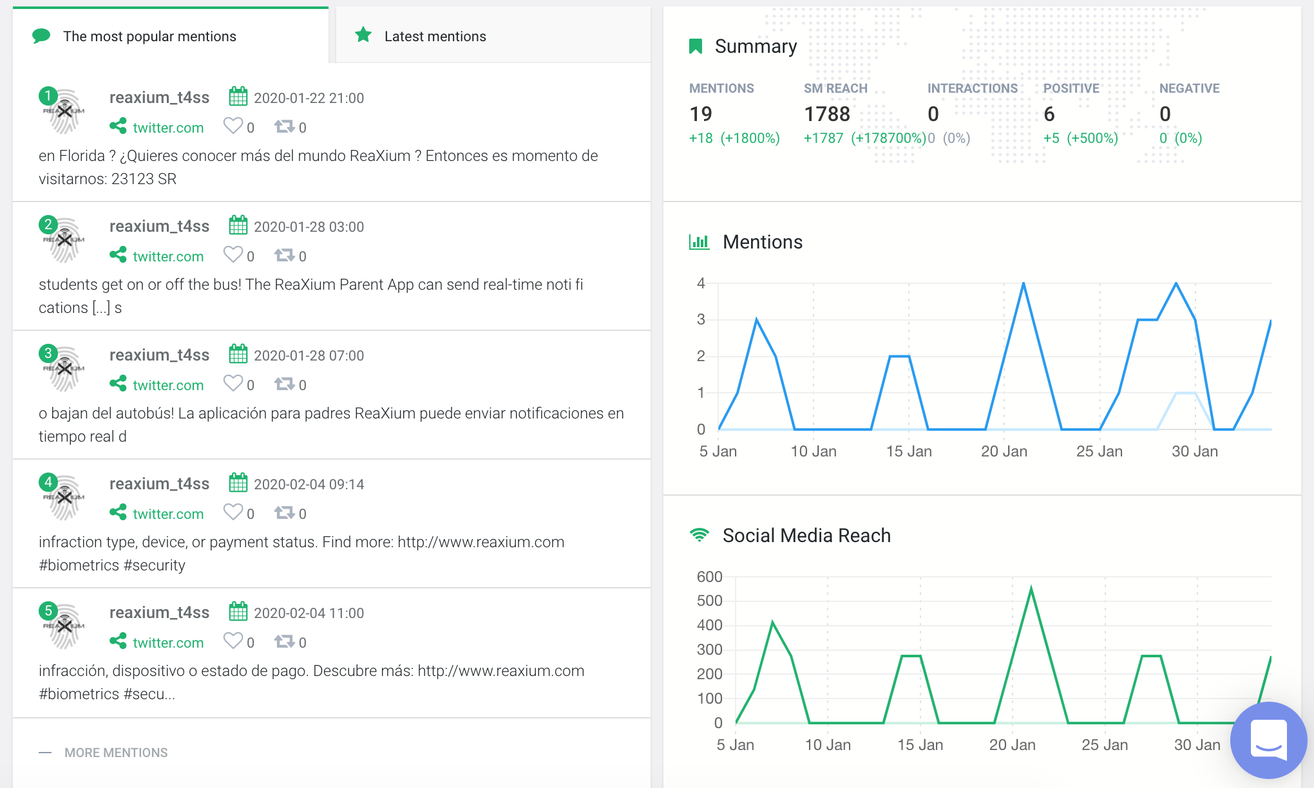
Retrieved from: https://app.brand24.com/panel/summary/?sid=463822269#d1=2020-01-05&d2=2020-02-04&dr=4&va=1&cdt=days
Regarding ReaXium's social media presence, the company posts the same information on each platform. ReaXium's most substantial following is on Instagram with 2,923 followers, and Twitter with 2,379 followers. The company has a total of 158 followers on Facebook, and 93 followers on LinkedIn. ReaXium's weakest social media presence is on YouTube because it only has 13 subscribers, although they are consistently posting videos. There is little to no interaction with the audience on any social media platforms, and the audience does not seem to engage with the organization either. Although ReaXium has over 2,000 followers on Instagram, they are only getting 1 to 3 likes on their Instagram posts. The number of posts also seem to be inconsistent. There are some days where they are posting back to back or even multiple times per day, and then there are some instances where the company goes 5-6 days without posting. These inconsistencies apply for Facebook, Twitter, Instagram, and LinkedIn. ReaXium's content is receiving the most attention from its followers when there is a video involved, whether that may be on Instagram, Facebook, Twitter, or LinkedIn. Videos are a beneficial strategy since they can be viewed multiple times and ensures the audience is paying attention to the information. IdentiMetrics has a much smaller following on their social media platforms. IdentiMetric's Instagram account only has 48 followers, 271 Twitter followers, 126 likes on its Facebook Page, and 42 followers on LinkedIn. The company does not post consistently but seems to have the same approach as ReaXium regarding posting the same images and information on each platform.
Conversationally there are not many people talking about the company itself other than ReaXium. ReaXium's CEO is in an interview for VoyageMIA, which is a Miami based Magazine. Edgar Zorrilla explains his background in technology and why he came up with the idea for ReaXium. This publicity shows the audience how passionate Zorrilla is for the company and what he is working on daily. Lake Wales Charter Schools' website also mentions ReaXium at the beginning of 2020 as they announce their usage of ReaXium's services for their bus riders. This article provides positive remarks about the product from credible people in the area, such as the Transportation Director. A screenshot of the article is below. The mentions show a strong sense of positivity for the company and its services, although there is not much of it available.

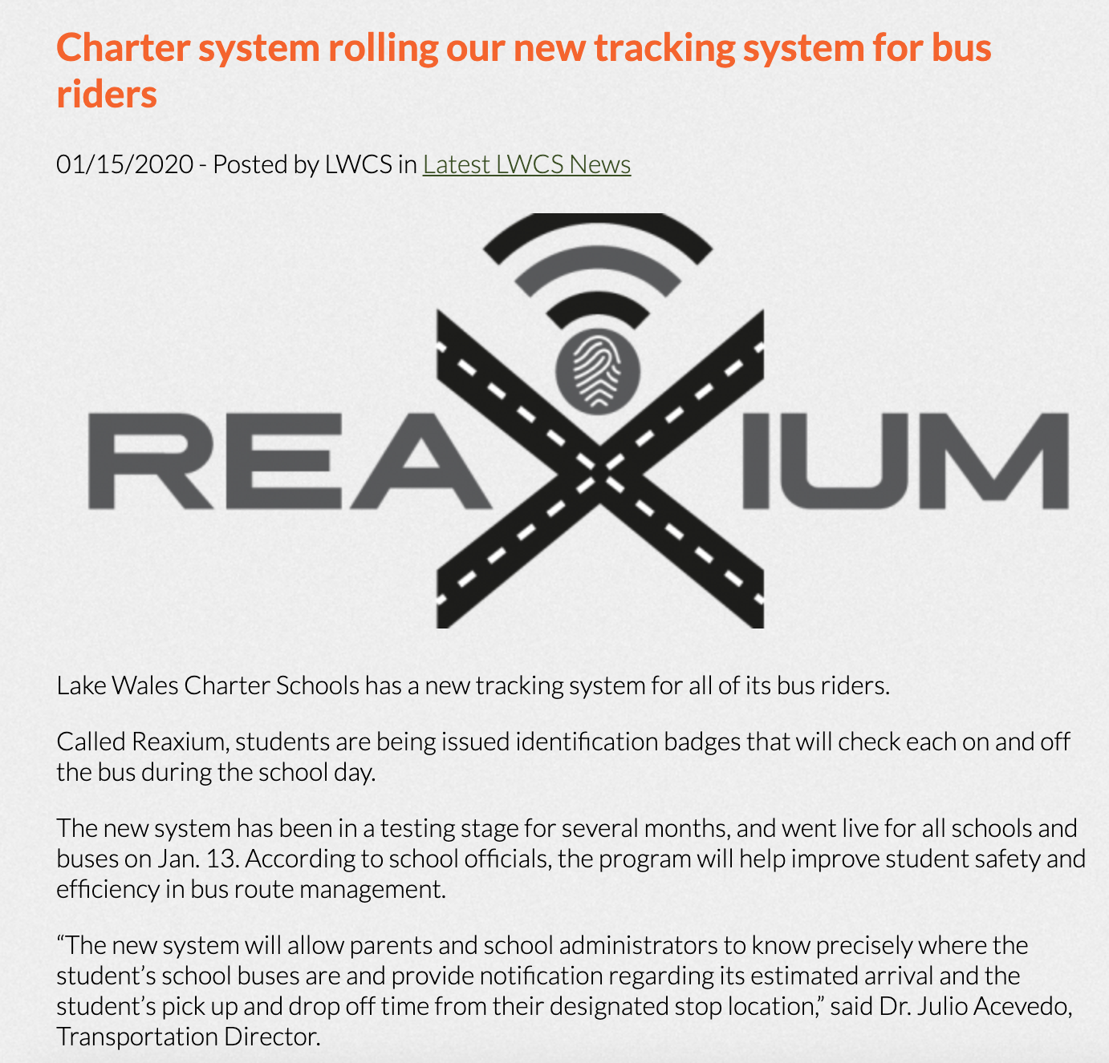
Retrieved from https://lwcharterschools.com/charter-system-rolling-our-new-tracking-system-for-bus-riders/

Overall, ReaXium has a strong search engine presence without paid advertising. The organization’s mentions and Social Media Reach were low, but all online interactions were positive. The only people talking about ReaXium is the company itself. Their main competitor, IdentiMetrics, did not show up in the search engine results and has a very weak online presence in social media. Resultant opportunities include having more engagement with their followers in order to have more mentions outside the company.

- Key Messages, Proof Points, and Sound Bites

- Key Message: ReaXium provides mobile biometric solutions to promote safety and efficiency for every community.
- Proof Points: Dr. Julio Acevedo Transportation Director for Lake Wales Charter Schools, says ReaXium is the “key to success for school safety” in an LWCS News article. “This brand is light years ahead of any company's technology and thought process with school safety precautions.” – Joe Fox, Facebook Comment. Over 50 schools in the South Florida area are using the solutions of ReaXium’s School Suite for School Bus and Classroom attendance.
- Sound Bites: Real-time security for real people. Providing solutions today for a safer tomorrow.

The reason I chose the key message for ReaXium is because one of the main objectives for the organization is to increase overall awareness of what they can provide to communities and what the company is all about. Therefore, I decided to use this as an opportunity to simply explain how the organization is benefiting the overall safety of the community. In order to emphasize this point even further, I chose the proof points above because they are from credible resources in the community. Since the organization has such a specific audience to target, it is important to acknowledge that audience in the proof points and key messaging tactics. I wanted the sound bites to be something that was short but easily can grab the attention of the target audience. Since the organization provides different types of security for all types of people, these sound bites can reach a wide variety of people in the south Florida region. Overall, I wanted to emphasize the organization’s passion for safety and helping others while promoting the types of organizations that they work with so that potential business partners can understand what type of clients the organization works with.

- Overview of Recommended Integrated Digital Strategy

The key strategic recommendations for ReaXium include creating a content strategy that allocates different types of content based on each social media platform to engage each audience and to create a community effectively. The organization can also buy paid Google Advertising to increase search engine results. By creating a brand ambassador program that is unpaid, the organization can increase brand awareness through influencers in the community that support the biometric field.
It is essential to recognize that there are different types of audiences based on each type of social platform. Therefore, since ReaXium wants to increase brand awareness overall while simultaneously building relationships with potential business partners, the organization needs to create content for each audience individually. By analyzing where each audience is most prevalent on each platform, the company can then understand what information needs to be seen by each audience based on what they are looking for when it comes to social media content. Creating a content strategy will provide organization for the company since they are currently posting the same content on each platform. The content strategy will identify where specific information about products, customer reviews, blog posts, and company information will be most effective for the intended audience. By providing a plan of creation, delivery, and maintenance of content, the marketing team will be able to have a better idea of how they can build different relationships with each of their audiences. Tactical elements of creating the content strategy for ReaXium include first creating a branding guide that will allow the organization to tie all of their content on each platform together in a cohesive manner. The website currently has a strong sense of branding for the organization. Therefore, the company needs to rebrand their social platforms based on the branding that they have on their website. Creating a consistent brand will allow potential business partners and future customers to recognize the company more efficiently. Following the rebranding of social media platforms to ensure that they are cohesive with the branding of the website, the marketing team needs to implement a strategy that ensures that the company is continuously checking social platforms to increase engagement with the target audiences. Therefore, the marketing team can designate a team member to each platform. That member is responsible for conversing with potential business partners, answering questions from clients, or participating in conversations relating to the organization on behalf of the company.
Paid advertising is another great way to increase brand awareness for customers at the beginning of the customer journey. Search engine optimization methods are a great way to ensure that curious customers and potential business partners immediately see ReaXium as an organization that they can look to that meets the criteria of what they are searching for online. Paid advertising allows companies to have an advantage over other competitors by having their company website shown higher on the search engine list. ReaXium currently uses Google Analytics as a tracking tool for specific measures regarding social media. Therefore, the organization can also invest in paid advertising through the Google search engine in order to track this information as well. Ensuring that potential clients and business partners are seeing that ReaXium invests in its advertising on search engines will overall increase brand awareness and show the target audience that the organization is efficient in their advertising methods.
ReaXium has a wide variety of clients since they provide biometric solutions for security companies as well as school districts. Therefore, it is crucial to engage with influencers that are not only in the target audience for the company but also have background experience in south Florida school districts or south Florida security systems. After researching organizations and their key members, I searched to find candidates that currently have a robust online presence in the social media community as well as their local communities. The keywords I used in order to search for influencers in the South Florida region included "school safety," "school security," "school systems," "security systems," "biometric solutions," and "mobile biometrics." I used Brand24 in order to find who was having conversations about these topics, and I also researched these hashtags on different social platforms such as Twitter. The most important criteria when looking for influencers is that they already have a strong relationship with the community and organization they work for and that they are active on their social media accounts. Influencers must agree to the specific amount of posts on the platform specified and must follow all social media accounts for ReaXium. When posting about ReaXium, the influencer must use the hashtag #Reaxium since this is the current hashtag the company uses across all social platforms and their website.
Influencers must also engage in activity with the social accounts of ReaXium, including liking and sharing posts, along with the creation of 5-10 original posts where specified. Influencers that are current clients with ReaXium will receive discounts off of their current biometric solutions by the company. Influencers that are not current clients of ReaXium will receive discount codes for people in their community for ReaXium products. The fee for Pilot Runs of all ReaXium products will be waived for referrals from any Influencers. Influencers are encouraged to attend the National Association for Pupil Transportation Annual Conference and Trade Show. Airfare/Hotel and Conference fees will be waived for influencers who attend. If influencers cannot attend, they must repost the media ReaXium posts while at the conference.

- Content Plan

The main goal of ReaXium is to increase its brand awareness on all social platforms that the company currently uses. These social platforms include Facebook, Twitter, Instagram, and LinkedIn. The company also wants to project the content on their blog. The blog, #ReaXium, consists of posts from internal employees regarding different products ReaXium offers as well as updates on current events happening in the mobile biometric solutions industry. The main reason the company wants to promote its brand more prominently on social media is that they want customers to gain a strong understanding of what products and services the company has to offer and what makes them unique from competitors.
ReaXium's target audience consists of men and women ages 30-55 in the South Florida area with experience in information services, information technologies, strategy consulting, and operation consulting. The objectives in place to reach the company's goal are to increase brand projection based on its customer's needs on different social platforms. More specifically, a higher forecast on LinkedIn and Facebook to create relations with potential business partners by providing relevant content. The company also plans to increase the usage of CTA's through cyclic lists on Twitter and creating a cohesive overall brand design on all platforms. ReaXium wants to include engaging content in its social platform routine in order to increase awareness of the company and to create conversations with customers, future customers, and potential business partners, which will ultimately lead to an increase in business as well as their audience.
Content Theme | Content Channels | Content Topics/Ideas | Timing/Frequency
- Trends in Biometrics Industry | - Blog Posts on #ReaXium  - Facebook Posts  - LinkedIn Posts | - Showcase Current Events happening on a Monthly basis for Biometrics Industry  - Showcase Breaking News in Biometrics Industry | - Current Events posted on a monthly basis  - Breaking news posted in real-time
- Customer Stories | - Instagram Posts  - Twitter Posts  - Blog Posts on #ReaXium | - Showcase a “Day in the Life” for companies who use ReaXium’s products/services  - Showcase the Before and After of how customers operate using ReaXium’s products/services | - “Day in the Life” posts once a week  - Rotate the platform the customer stories are posted on and link the stories on the other two platforms
- Video Q&A Tutorials for ReaXium Products | - Instagram Posts  - Facebook Posts  - LinkedIn Posts | - Create Video Tutorials on specific products based on FAQ’s asked by customers/potential customers | - Videos will have a theme each week based on certain product/service for that week.  - Videos will be posted once a week

- Content Themes
Since one of ReaXium's goals is to increase relations with potential business partners, creating content focusing on current trends in the biometrics industry will initiate conversations between the organization and other companies that may look into the technologies related to biometrics. These conversations will become ongoing and will keep the organization relevant to others in the related industries. Customer stories will allow the organization to increase its brand awareness and promote positive media based on the review of its current customers' experiences with the products, services, and organization as a whole. Since most consumers rely on customer reviews when turning to research, these positive reinforcements of what ReaXium can bring to future clients can lead others to move forward in the customer journey. Video Q&A tutorials require engagement with the target audience and will be beneficial towards the organization's goal of increasing awareness to customers about what products and services the organization provides. Using these themes as a combined strategy in a content plan will allow ReaXium to fulfill its goals of creating a strong overall brand presence. These themes tie back to the key messages of the organization of the community. ReaXium's primary goal as an organization is to create a safe and efficient community for its customers. Therefore, using these themes will allow the target audience to recognize the community that ReaXium is building.

- Content Channels
When choosing channels for each content theme, it is vital to recognize that different members of the target audience are looking for different types of content based on specific social platforms. For example, one of ReaXium's goals is to increase relationships with potential business partners, which they find are most active on Facebook and LinkedIn. Therefore, sharing information on trends in the biometrics industry on these platforms will engage potential business partners to read into what is going on in the industry and how the technologies that ReaXium uses are beneficial to communities. Potential business partners can be considered potential stakeholders. Therefore, stakeholders want to ensure organizations are staying up to date with what is going on in the specific industry and how that affects the organization. Blog posts will also allow current customers or potential customers to gain an understanding of the benefits of the biometrics industry. They can be confident that the organization is staying current with the technologies they are providing to their customers. ReaXium also wants to increase brand awareness on social platforms and using customer stories for content should be accessible to the target audience on platforms that customers are frequently checking, such as Instagram and Twitter. Instagram is a great way to engage with the target audience by providing images and videos, along with longer posts about what the content entails. Showing the real customer stories behind ReaXium and how they have been able to change the lives of so many will allow customers to share their experiences directly with other members on these social platforms in an instant, which will increase the company's overall reach. Another primary goal of ReaXium is to provide the target audience with information about the products and services they have. Therefore, using frequently asked questions from past clients will allow the target audience to see what products the company has, how they work, and how they can be beneficial to their organization. This type of content can also go on Instagram since the social platform has those capabilities. When new members of the target audience come to follow the organization on Instagram, or like their page on Facebook, they will automatically gain information about how they can benefit from the company. ReaXium is currently active on all of these platforms. Therefore, they have a strong understanding of how to post content onto each of these platforms. Since the organization also wants to increase its usage of CTA's, CTA's can also be used on any of these platforms depending on whether they would like to link content from Facebook to their blog, or vice versa.

- Content Topic/Ideas
The two major industries that use ReaXium's products include security and transportation departments of school districts and security companies. In order to increase relationships with potential business partners, potential partners need to be confident that the organization has a strong understanding of the biometrics industry themselves. By showing potential business partners that the ReaXium is invested in what is going on in the industry as a whole, it will show that the organization cares to let business partners and customers understand why biometric solutions are so essential to enhancing the safety and security of our future. Therefore, providing these consumers with up to date information every month will showcase that ReaXium wants to provide the absolute best in terms of products and services for the community. Releasing breaking news in the industry will also show that the organization is monitoring this information in real-time. Regarding the topics of customer stories, a day in the life will allow the target audience to understand how customers are using the products and services provided by ReaXium in their daily routines. Therefore, these routines can look different depending on what type of client is using the products. Providing days in the life of customers who work in the school system, as well as people who work in security, will allow the target audience to see how different types of organizations can benefit from the products in different ways. Before and after posts will show how the company's strategy changes due to the implementation of ReaXium's products. The target audience will be able to witness the positive benefits that come from the accessibility of the products and services that ReaXium provides. Organizations will see that they have the ability to do their job in a more timely and efficient manner with systems provided by the company. Providing videos based on questions asked by previous clients will make the services seem more approachable to members of the target audience who are unsure of what the products do. These videos will include the set-up of different products and the underlying fundamental questions of how they work. These videos will enable the target audience to gain an understanding of how these products can work for their organization so they can feel comfortable when approaching the company about demos. ReaXium is continuously building new products and services that they can provide to communities based on the advancements in biometric technologies. Eventually, there will be products for new types of clients other than school districts and security offices, which will allow other members of the target audience to see how these products can be beneficial to their company as well.

- Timing/Frequency
Posting monthly updates of what is happening in the biometrics industry will allow the target audience to set aside time at the beginning of each month to see what is going on. Breaking news in the industry should be happening in real-time to show the target audience that the company is actively monitoring the changes happening in the industry. By rotating the platform that customer story content is posted on the organization will allow the target audience to gain exposure to all forms of social platforms that the company is active on, which is one of their goals. The organization can dedicate customer story posts to one specific day and Q&A videos to another specific day. The organization can collaborate on the customer story and Q&A video based on specific products or services highlighted for that week. For example, one week can be dedicated to school safety. The customer story can come from the transportation department of a school district that uses ReaXium, and the Q&A video will show how the schools use the product as well as how to set it up and how it works.
ReaXium's marketing and design team currently use Social Gest to schedule, analyze, and monitor the content they are posting to all of their social platforms. Therefore, the team should be using the platform that they are most comfortable with and should use this social media strategy tool moving forward. By using the same tools, the organization will be able to see how the changes in the content strategy have increased their performance metrics based on the previous content they were posting. All of the content posts can be on an automatic schedule except for the breaking news for the trends happening in the biometrics industry. Posting this content in real-time will allow the organization to effectively approach the audience relative to the time that the news was released. The organization should also see what days their audiences are most active on what platforms in order to decide what day to dedicate to each post. For example, if most users are active on Instagram on Mondays and Fridays, the organization should be posting content on Instagram for customer stories on Mondays and Q&A videos on Fridays. This strategy also applies to certain times of day that each target audience is most active. Dedicating days to each platform for different posts will allow the target audience to know where they can receive different types of content. Although content can be automatic, it is essential to thoroughly check that the correct content is going to the correct platform on a specific day. Since the marketing and design team was previously posting the same content to each social platform, they will need to adjust and create a quality assurance plan in order to confirm that the posting for each platform is placed correctly. For the content theme of trends in the biometric industry, the marketing and design team will automate verbiage and a link to the blog post on Facebook and LinkedIn at the beginning of each month. For the customer story content theme, the team will rotate weekly the main post of the content, whether that may be Instagram, Twitter, or on the blog #Reaxium. The team will automate a post once a week with an image, verbiage, and a link to the main platform of where the customer story is posted. For example, if the customer story is on the blog #ReaXium, posts on Instagram and Twitter will have verbiage pertaining to the customer story, an image of the customer, as well as a link to the direct customer story. The same strategy will be used for the Q&A videos, expect the platforms will be Instagram, LinkedIn, and Facebook. Using the rotation of social platforms will allow the target audience to gain access to all of the organization’s social media and increase activity.

- Measuring Success

When measuring success in terms of numbers, one of the main goals of ReaXium is to increase overall brand awareness on all social platforms. This refers to how much traffic each social platform is receiving, and how many people in the target audience are commenting, liking, and sharing the content from ReaXium. Below are three metrics for measuring success among the implementation of this Digital PR Strategy:

- Increase Social Media reach by 30% to reach at least 2,324 mentions by end of Q4.
- Increase Social Media mentions by 50% to reach 28 mentions by end of Q4.
- Increase in the number of sales of products/services along with increase in number of clientele and potential business partners by the end of Q4.

Achieving these objectives will be a direct impact from the strategies implemented through the use of a social media calendar, paid advertising, as well as ensuring that the ambassador program is growing on a monthly basis. With this Digital PR Strategy, ReaXium will be portraying the right content to the right audiences as opposed to what they are doing now, which is portraying the same content across 5 different social media platforms. This will allow each different audience the chance to engage with the organization and to build relationships with the customers, future customers, and potential business partners. Although numbers are not the only way to define success in terms of a PR strategy, I believe that these numbers will be important to the organization in order to show an increase in reach. When presenting this information to higher management in the organization, they want to see tangible outcomes from money that they invest in the company’s marketing efforts. Therefore, having these numbers will be a great support system for the marketing team to ensure that what they are doing is overall increasing the reach and sales of the company. An increase in relationships with potential business partners is also very important to the organization’s goals since it will allow the organization to potentially add new ambassadors to the organization and to also ensure that they are building a larger community for the ReaXium customers.

